International Digestive Endoscopy Network (IDEN 2026)
Abstract Submission Deadline: March 15, 2026
Go to submit: Click here

Registration fees for accepted abstract presenters will be refunded after the conference.

WE INVITE YOU TO THE IDEN 2026 CONFERENCE AT THE GRAND WALKERHILL SEOUL!
Since the first IDEN conference was held in 2011, IDEN has accomplished steady growth, with the most recent conference attracting about 1,000 participants from 37 countries.

IDEN 2026 will be the perfect occasion for us to catch up on the rapidly changing developments and innovations in the advanced digestive endoscopy field.

- Conference Overview
Title | The 16th Conference of the International Digestive Endoscopy Network (IDEN 2026)
Date | June 11 (Thu) - 13 (Sat), 2026
Venue | Grand Walkerhill Seoul, Korea
Participants | - Digestive endoscopy society members and chairpersons.  - Doctors, nurses, students, residents, technicians in the field of digestive endoscopy  - Pharmaceutical companies, medical device manufacturers
Scale | - 1,200 Participants from 37 countries  - About 300 Presentations  - 27 Sponsors and 59 Exhibition Booths
Organized by | International Digestive Endoscopy Network (IDEN)  Korean Society of Gastrointestinal Endoscopy (KSGE)
Official Language | English
Website | https://www.idenworld.org/event/291/
Programs | Invited Sessions, Joint Sessions (ASGE, Asian Network), Spotlight Session, Live Demonstration, Excellent Poster Presentation, Poster Exhibition, International Young Endoscopist Awards (IYEA) 2026, Luncheon Symposium, Satellite Symposium, Exhibition
Key Dates | Abstract Submission Deadline Notification of Abstract Acceptance  Pre-Registration Deadline | March 15, 2026  March 31, 2026  May 22, 2026
Key Dates | ※ For more details, please visit the IDEN 2026 website.
Secretariat | IDEN Membership: International Digestive Endoscopy Network  Tel. +82-2-336-1554 l Fax +82-2-335-2690 l Email admin@iden.or.kr  Registration & Scientific Program & IYEA: IDEN 2026 Secretariat (P&M)  Tel. +82-2-557-8422, 8423 l Fax +82-2-557-8428  Email (General) info@iden.or.kr (IYEA) iyea@iden.or.kr

- Program at a Glance
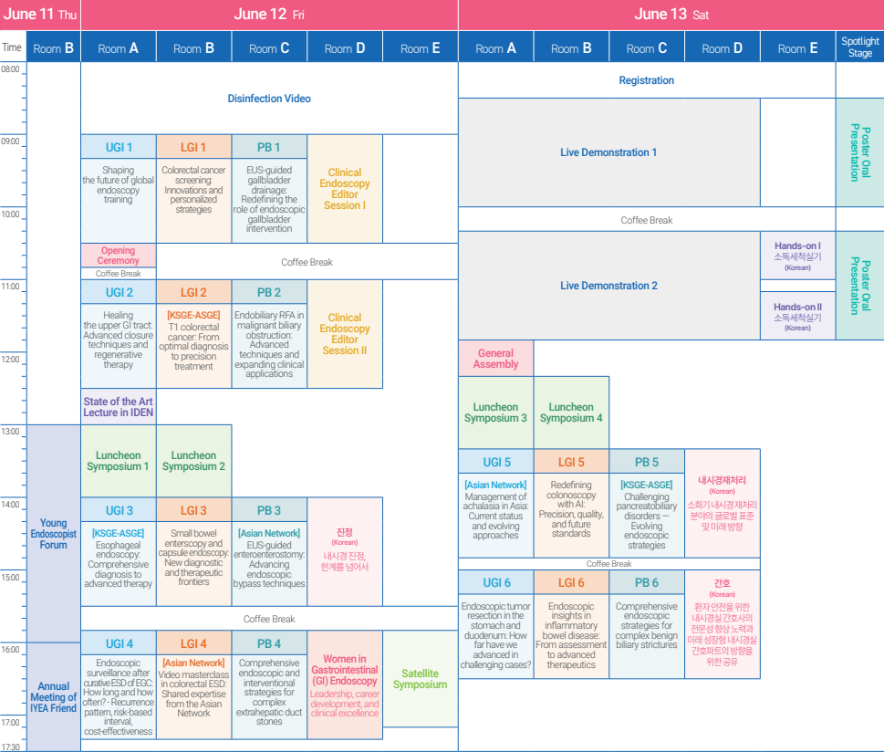

- Abstract Topic Categories
Abstract Submission Deadline: March 15, 2026
· Upper GI tract | · Pediatric Endoscopy
· Lower GI tract | · Others
· Pancreatobiliary

- Travel Grants & Awards
Awards | Travel Grants | Young Investigator Award | Best Poster Award
Prize | USD 500 | USD 300 | USD 300
Eligibility | - The presenter must complete registration, attend the conference on-site, and submit E-Poster prior to the conference.  - The applicant must be a presenter of an abstract accepted for Poster presentation. (Corresponding authors and co-authors are not eligible).  - The presenter must complete registration and attend the conference on-site.
Eligibility | Presenters must reside outside of Korea. | Presenters must be under the age of 40  (Year of birth: 1986 or after).

- Registration Fees
Pre-Registration Deadline: May 22, 2026
Category | Membership Fee | Pre-registration  (Until May 22, 2026) |  | General Registration  (From May 23, 2026)
Category | Membership Fee | IDEN Member | Non-Member | IDEN Member | Non-Member
Participant  (Physician/Specialist/Fellow/Professor) | USD 100 | USD 150 | USD 300 | USD 200 | USD 350
Intern/Trainee/Resident | USD 50 | USD 80 | USD 150 | USD 100 | USD 170
Student/Radiologist/Technician | USD 50 | USD 20 | USD 80 | USD 40 | USD 100
Nurse
- Registration fees (except for the IDEN membership fee) for poster presenting authors will be refunded after the conference.
- Senior IDEN members 65 and over will receive complimentary registration.
- WEO-endorsed benefit: WEO members receive 15% off registration.

